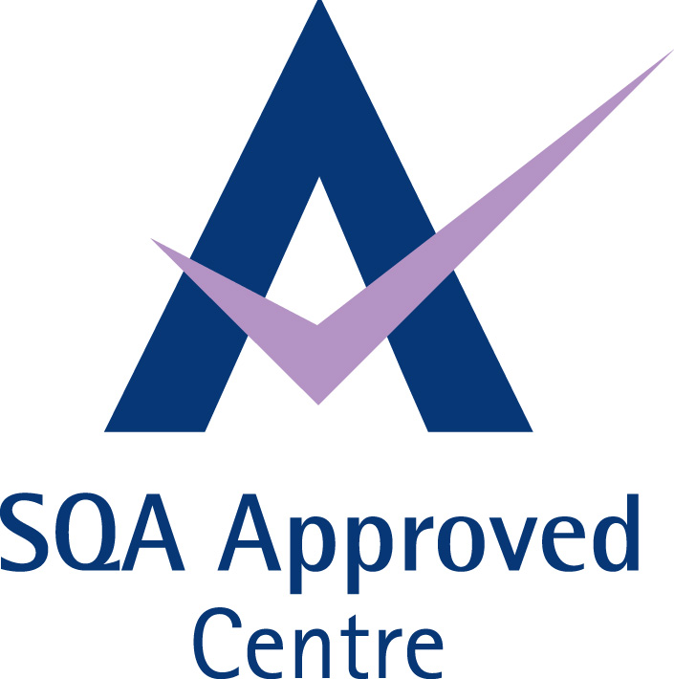

PLANNING AND DELIVERING TRAINING SESSIONS TO GROUPS
SCQF level 6
Confirmation of Booking
Name of Company:

Contact Name:
Business Address:

Tel No:
Fax No:
Email:

 | Timings | Venue
Workshop 1  Workshop 2  Workshop 3 | 5 September 2017 930 - 1700  6 September 2017 0930 – 1700  13 September 2017 0930 - 1700 | Quest  8 Riverside Court  Mayo Avenue  Dundee  DD2 1XD  Tel 01382 668760
Number of Delegates Attending
Name of Delegates and email addresses
Price | £600 + VAT or Book two people for £1100 + VAT (for two).
Payment must be received in advance of the workshops and ILA numbers processed at least 2 weeks beforehand. You can pay by credit card on line: www.questscotland.co.uk or if you would like invoice please tick here □
Payment should be received in advance of the workshop.

Cancellation: In the event of cancellation an appropriate fee will be charged depending on the notice given. Notification should be made in writing. If less than one weeks’ notice is given then the full fee will be charged: between 1 and 2 weeks 50% will be charged.

Print Name:…………………………………………Signed……………………………… Job Title……………………………………..
Please return booking form to 8 Riverside Court, Mayo Avenue, Dundee, DD2 1XD or email it to laura@questscotland.co.uk

