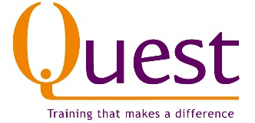
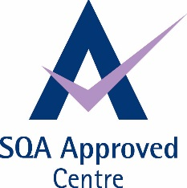
Customer Service Award – SCQF level 5
Quest identified a gap in qualifications recently and submitted a business case to SQA for a new ‘vocational’ Customer Service qualification. Our thinking was that there were volunteers and people on short employability programmes who were dealing with customers who could actually achieve a qualification whilst doing this work. There are also many people working in customer service roles.
There were qualifications such as Worldhost but these were taught programmes and we wanted something which was assessed.
So as a result we are delighted to announce that there is now a new qualification called an Award in Customer Service which sits at level 5 on the Scottish Qualifications Credit Framework. It involves completing 2 units
One mandatory unit - Give Customers a Positive Impression of Yourself and Your Organisation - U(H9XK04)
And then one from the list below.
Deal with Customers Face to Face - U(H9XR04)
Deal with Customers in Writing or Electronically - U(H9XW04)
Deal with Incoming Telephone Calls from Customers - U(H9XT04)
Make Telephone Calls to Customers - U(H9XV04)
Deliver Reliable Customer Service - U(FE1V04)
Resolve Customer Service Problems - U(H9YD04)
Deal with Customers Using a Social Media Platform - U(H9Y004)

We feel it has a number of benefits
- It can be offered to volunteers, staff, people on work experience, helping these people achieve a nationally recognised qualification
- It will be approved as an Individual Learning Account programme, so learners could get £200 towards completion.
- For more information please get in touch.
Quest will charge £250 + Vat for this qualification and as we are an ILA Centre it could be a qualification achieved for £50 + VAT.
Or if you are an employer with less than 100 staff you could apply for Flexible Training Opportunities funding which would pay for half of the cost.

